Baraka Basenji
Celebrating a Great Dam and Her Three New Champions
Litter sired by GCh DC Southhouse Jumoke Ltle Man Malawi SC FCh
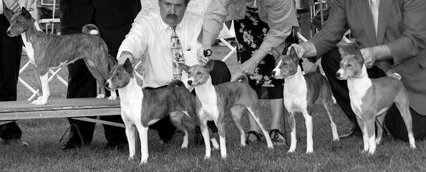
Am/Can DC UCI Int Ch UCI Int/Nat JA Jumoke's Saylah of Baraka SC FCh JOR MBIF BISP
EBC 2010 Specialty – Brood Bitch
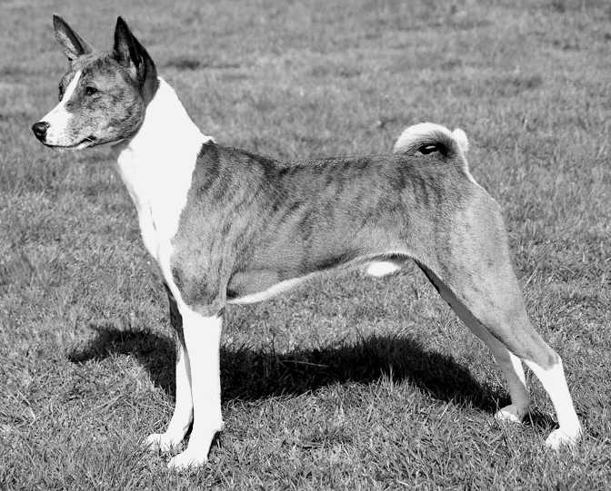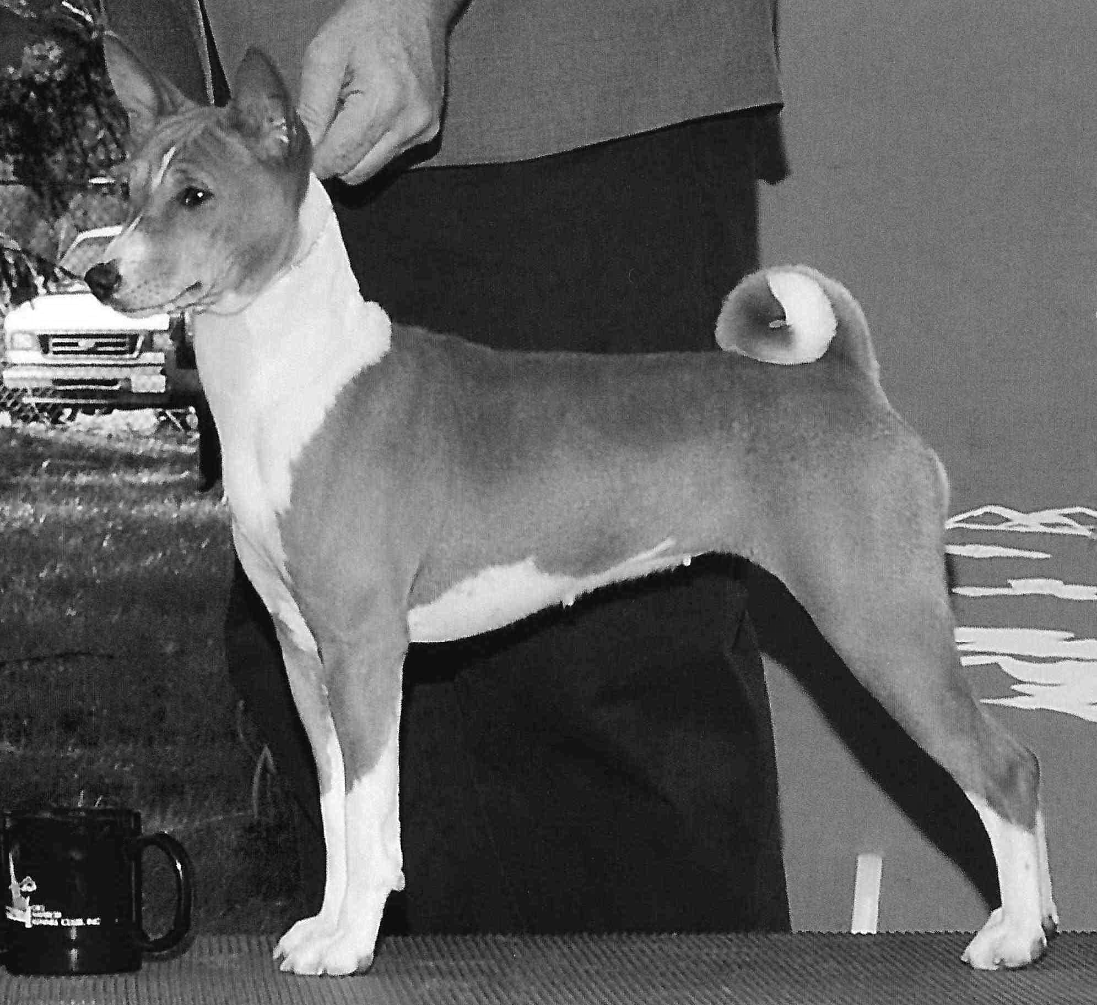
CH Jumoke Baraka Salish Samish Can CH Baraka Jumoke Salish Lummi QC
BCOA 2010 National Specialty – Class Winner BCOA 2010 National Sweeps – BOS
EBC 2010 Specialty – Best in Futurity
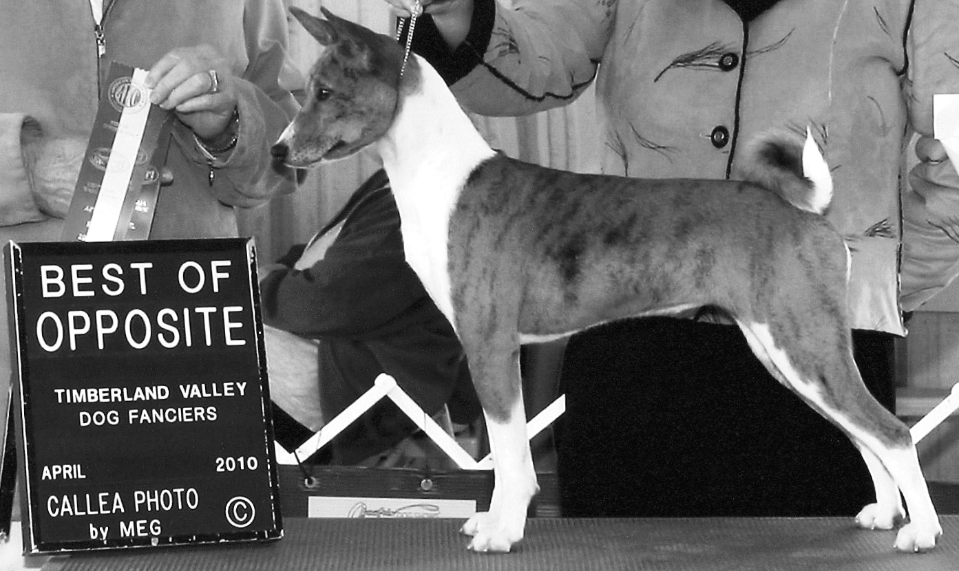
CH Salish Sea’s Baraka Jumoke Ms Diamond JC
Baraka Basenji – Paul and Bill Bowlus-Root – BRINC@brincnet.com – http://www.BarakaBasenji.com
Photo Credits: Saylah and Samish – Laurie Gregory / Lummi – Randy Roberts / Ms Diamond – Callea Photo

